
Qwwdq
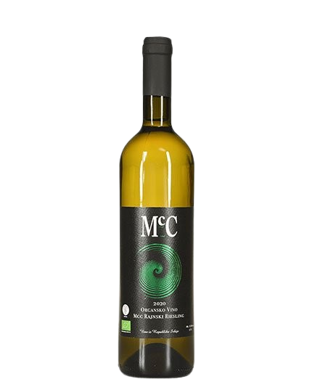
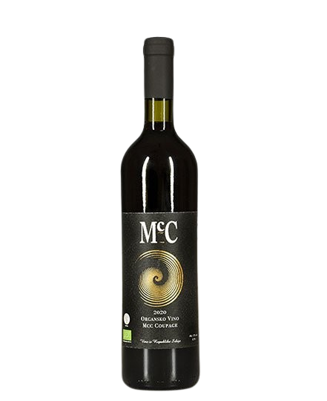

RAJNSKI RIESLING

- Dry white wine- -

About the vine

Grape varieties:
- Rajnski riesling
Origin: Erdevik, Fruška Gora
Serving temperature:10-12 ºC

The wine has a pronounced varietal character, with a greenish-yellow color and aromas of apple, peach, and rose, with violet notes in the background. On the palate, it is well-balanced with fresh, pronounced acidity, along with petrol notes, especially in our more mature wines.
Food pairings include ham, caviar, tuna pâté, smoked salmon, carp in wine sauce, pike-perch in sour cream, grilled chicken, all types of roasted meats, and semi-hard cheeses.
We produce an average of around 3,000–4,000 bottles of Riesling per year.

Awards

2023 – The 2018 Riesling won a silver medal at the Wine Vision by Open Balkan.
2022 – The 2017 and 2020 Riesling vintages both won silver medals at the Wine Vision by Open Balkan.
2021 – The 2017 vintage won a silver medal at the Rivica Wine & Food Festival.
2020 – The 2017 vintage won a silver medal at the Saint Trifun Celebration.
2015 – The 2012 vintage won a gold medal at the Gastro Fest.

